

Module Code & Module Title
CS6P05NI Final Year Project
Assessment Weightage & Type
5% FYP Proposal
Semester
2024 Autumn
PROJECT TITLE: School Management System
Student Name: Aagaman Mainali
London Met ID: 22068131
College ID: np01cp4a220472
Internal Supervisor: Subin Chitrakar
External Supervisor: Rubek joshi
Assignment Due Date: 12/4/2024
Assignment Submission Date: 12/4/2024
Word Count: 261

I confirm that I understand my coursework needs to be submitted online via Google Classroom under the relevant module page before the deadline in order for my assignment to be accepted and marked. I am fully aware that late submissions will be treated as non-submission and a mark of zero will be awarded.

Table of Contents
1. Introduction: 2
2. Aims and Objectives 4
2.1 Aim: 4
2.2 Objectives 4
3. Expected Outcomes and Deliverables 5
4. Risk and contingency plan 6
5 Methodologies: 7
5.1 Considered Methodology: 7
5.1.1 Feature-Driven Development (FDD) : 7
5.2.2 Agile Scrum: 8
5.2 Selected Methodology: 9
6. Resource Requirements: 10
6.1 Hardware Requirements: 10
6.2 Software Requirements: 10
7. Work Breakdown Structure: 12
How WBS Helped in My Project: 12
8.Milestones: 13
9.Gantt Chart: 14
10.Conclusion: 15
11. Bibliography: 16

Table of Figures

Figure 1:Increase in School Management software (MordorIntelligence, 2024) 2
Figure 2 : Development process for FDD model (Grorapid Labs, 20024) 7
Figure 3 : Process involved during scrum (Bhaskar S, 2024) 8
Figure 4: Kanban Board for Software development (Simon Buehring, 2024) 9
Figure 5: Work Breakdown Structure for the system. 12
Figure 6 : Milestone Timeline for the System 13
Figure 7: Gantt chart of the overall system 14

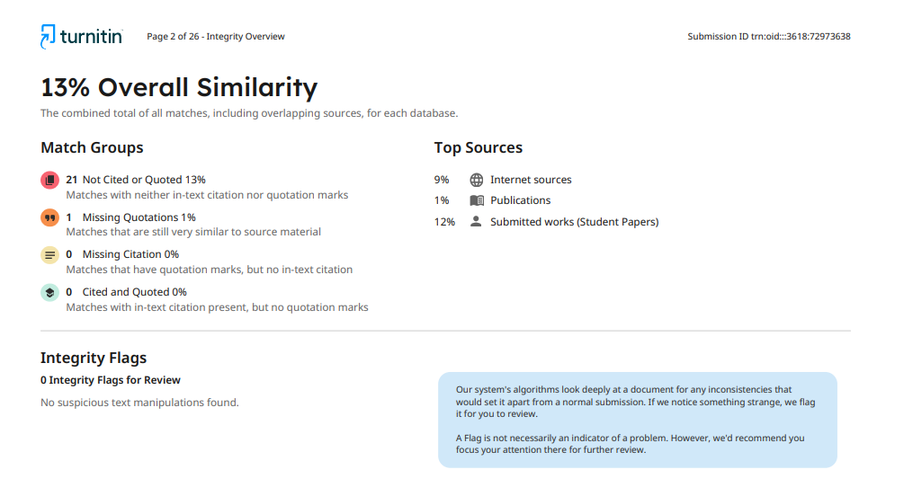
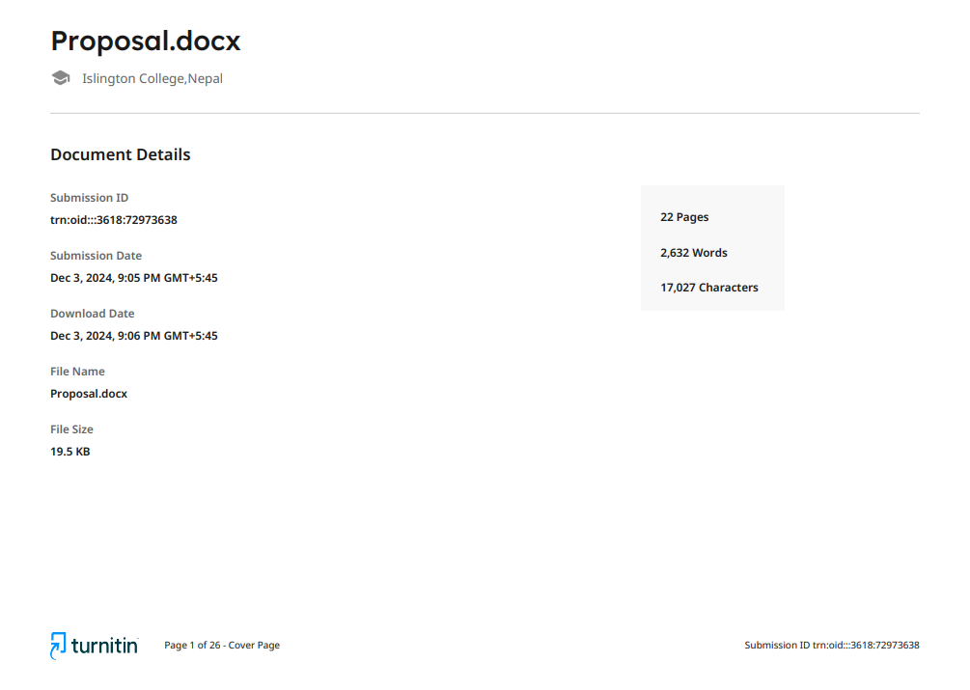

NOTE: [ Reference to appendix for further information Appendix ]

1. Introduction:
Administrative tasks like maintaining student attendance, handling grades, processing funds, and keeping records are frequently done by hands in traditional educational institutions. These procedures usually use outdated software or paper-based methods, which results in inefficiencies, human error, and a delay in information exchange (theschoolmanagement, 2024) . There is little opportunity to enhance the overall educational experience because teachers and administrators spend a lot of time on repetitive tasks.

The School Management System (SMS), on the other hand, provides an advanced solution that organizes and automates these essential tasks, greatly improving the accuracy and efficiency of school operations. SMS removes the need for manual data entry and paper-based records by digitizing procedures including student enrollment, attendance tracking, grade management, and fee collecting. Additionally, the system guarantees that parents, teachers, and kids have real-time access to critical information, which promotes improved communication and prompt decision-making. The SMS additionally shields private information from unwanted access thanks to its integrated security features. The School Management System is an essential tool for modern schools since, in contrast to old approaches, it improves overall management of educational institutions, minimizes errors, and streamlines administrative operations.
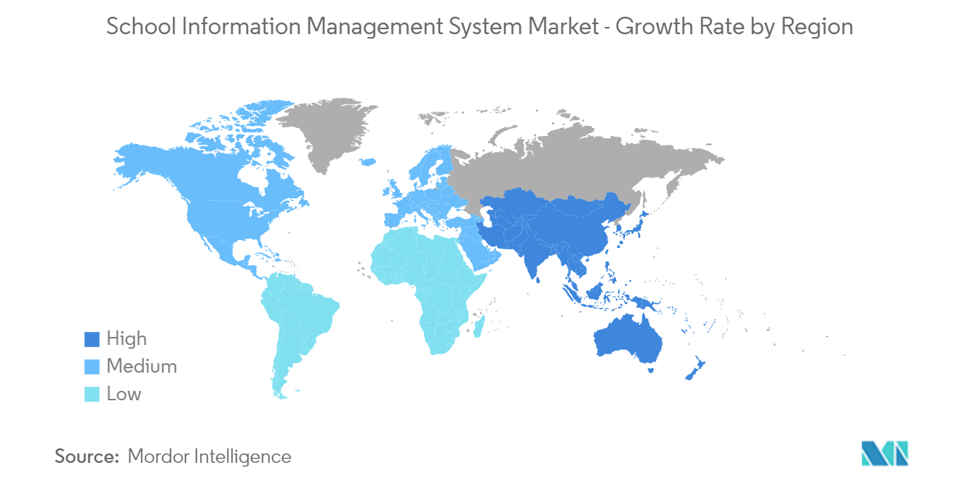
`
Figure 1:Increase in School Management software (MordorIntelligence, 2024)
In the era of digitalization, educational institutions are under increasing pressure to improve student engagement and optimize their administrative procedures. Traditional systems frequently use manual processes, which cause delays, mistakes, and inefficiencies. A study published by the U.S. Department of Education’s National Center for Education Statistics, as of 2022, 75% of public schools reported using cloud-based systems for at least some of their administrative functions (Verified Market Research, 2024) .
In Nepal, however, many educational institutions still face significant challenges due to a lack of streamlined platforms for managing various educational and administrative tasks. As a result, administrators and students experience a decentralized approach to communication and data management. These inefficiencies can hinder academic achievement, lower student satisfaction, and limit the potential for institutional growth and development. (edigitalnepal, 2024)
The need for modernization is becoming more and more obvious, even if Nepal's educational system is digitizing more slowly than other developed countries. Many institutions encounter obstacles including inadequate funding and shortages in technology expertise. However, the advantages of switching to a digital system enhancing communication, streamlining administrative procedures, and improving learning outcomes are becoming increasingly clear.
This is where this project is useful. By providing a comprehensive, cloud-based solution that improves administrative tasks and student participation, the proposed educational system seeks to eliminate the current inefficiencies. The system will have several features that are intended to automate and streamline important procedures in educational establishments, facilitating communication between staff, students, and administrators. These characteristics, which provide flexibility and scalability for educational institutions of various sizes, are specifically designed to meet the demands of Nepal's educational environment.

2. Aims and Objectives

2.1 Aim:
Enhancing Traditional schooling system: This project's main goal is to create a School Management System that improves student involvement through constant updates and notifications while reducing administrative operations. The system will use modern technology to automate essential processes including student enrollment, attendance tracking, grade management, and fee collecting.

2.2 Objectives
- Affordable Access to Technology: By end of April 2024, design and implement a cost-effective educational management system that aligns with the budget constraints of 80% of educational institutions in Nepal, ensuring its affordability and sustainability.
- Improvement of Administrative Efficiency: Reduce the amount of paper-based administrative work by 50% within the first six months of deployment by automating procedures including event registration, fee collecting, student enrollment, and attendance tracking.
- Commitment to the law and regulations: Verify that the system satisfies all local laws regarding security, privacy, and education under Nepal’s Personal Data Protection Act.
- Promoting Student Engagement and Learning: E By implementing features like event registration, exam management, and real-time notifications of academic activities, increase student involvement by 40% in the first academic year.
- Automated Attendance Recording (Future Work): In the coming Future integrate a fingerprint-based attendance system that automates attendance tracking, aiming to eliminate manual record-keeping and reduce errors by 90%.
- Administrative Tools: Launch a complete admin page with CMS features, enabling administrators to efficiently manage notifications, schedule events, and create and update content, reducing administrative workload by 30%.

3. Expected Outcomes and Deliverables
Upon project completion, the system will include several features and capabilities. Below is a list of the deliverables that are expected out of the system:
- To guarantee that only authorized users may use the system, users should be able to safely register and log in after authorizing successfully.
- The system allows registered users to sign up for various events, making it simple to participate in school events.
- Users will receive reminders from the system when there are significant changes, like events or holidays. As soon as the administrator adds a notification, it is delivered.
- Based on the curriculum, teachers will be able to create multiple-choice questions (MCQs) for assessments given to small groups of students. After completing the assessments, students will turn in their responses for evaluation.
- Students have the option to complete a contact form, which will be forwarded straight to the administrator for evaluation and take further action.
- To make sure that all users are informed of official holidays, administrators can add holidays on the site.
- Administrators can track attendance by uploading attendance sheets, analyze it and create reports for each individual student.
- Students can enroll by downloading a PDF form to manually fill out and submit, or by completing an online form.
- Accountant admin will manage fee collection, ensuring that users can track pending and paid fees. Payment records will be accessible and maintainable for financial reporting.

4. Risk and contingency plan
Due to the project bring developed under time and budget constraints there are a lot of risk involved with the project some of them are as follow with measures to solve them:
Risk Involved | Description | Contingency Plan
Event Registration | Users repeatedly submitting event forms, causing duplicate entries. | Enable Limit to 1 Response in Google Form settings
Report Generation Delay | Large datasets of student data causing delay in generating reports | Use optimized queries to extract data, Implement batch processing of files
Fake Account Creation | Users creating fake accounts to manipulate or misuse the system | Use email or phone number verification for account creation.
User Authentication Failures | Users may face issues while logging in or registering due to incorrect authentication mechanisms | Use Multiple way to login such as login through email, phone or Username
Feature Extension | Client may request for additional  feature which may change the project scope and delivery time | Set fixed boundaries for the project scope and prioritize core features.

5 Methodologies:
The systematic approach or frameworks used to plan, design, develop, test, and maintain websites and online applications are referred to as methodologies in web development. They offer a methodical approach to project management, guarantee effective teamwork, and produce high-quality outcomes on schedule. Well-known approaches like Agile, Scrum, Kanban and Waterfall provide detailed instructions for allocating responsibilities, setting priorities for developments, and managing modifications. Methodologies are crucial in web development because they help control complexity, enhance team communication, guarantee consistency, and lower the possibility of mistakes, all of which contribute to the creation of more successful, efficient, and user-friendly online solutions.

5.1 Considered Methodology:

5.1.1 Feature-Driven Development (FDD) :
Feature-Driven Development (FDD) was also considered for this project due to its focus on building software through feature-specific tasks, making it well-suited for modular components like user authentication, event registration, and notifications. This methodology provides clear deliverables and iterative progress, which aligns with the project's need for structured development. However, it was not selected because it is more suitable for larger teams and complex projects. Kanban, with its simplicity, flexibility, and visual task tracking, was a better fit for this smaller-scale project, ensuring efficient task management and adaptability
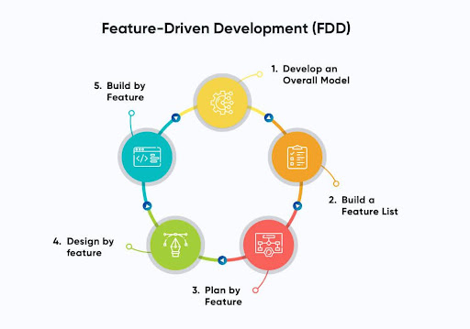

Figure 2 : Development process for FDD model (Grorapid Labs, 20024)

5.2.2 Agile Scrum:
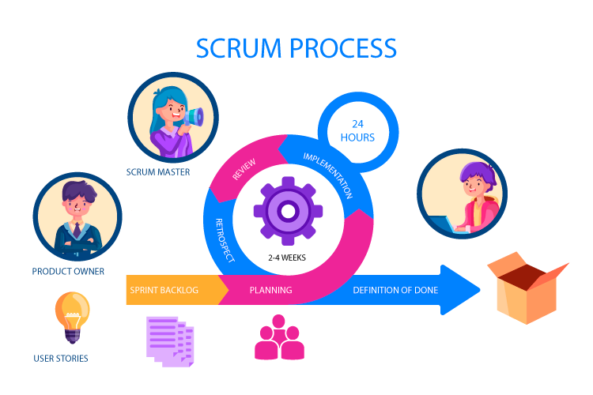
Scrum was taken into consideration because of its systematic approach to continuous improvement using sprints, which enables regular feedback and systematic progress for features like user authentication and event management. But because of its formal procedures and role requirements, which were too complicated for a small team, it was not selected. For this project, kanban's continuous process and simplicity were thought to be more suitable.
Figure 3 : Process involved during scrum (Bhaskar S, 2024)

5.2 Selected Methodology:
Among various methodologies, Kanban from Agile was selected as Kanban is a methodology from Agile that helps organize work efficiently by visualizing tasks and identifying problems It uses a visual board with task cards to track progress, reduce waste, and improve workflow. This structured approach ensures timely completion of tasks. Ultimately, Kanban boosts productivity and quality.
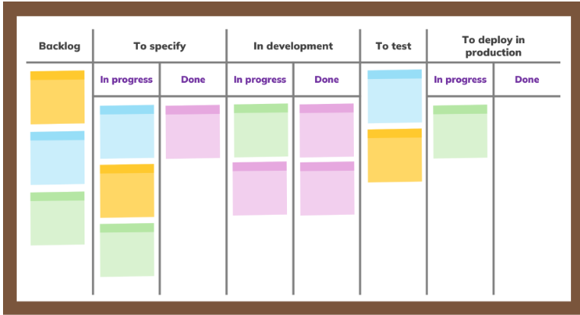

Figure 4: Kanban Board for Software development (Simon Buehring, 2024)

Reason for choosing Kanban for the project:

- Kanban in this project helped to quickly identify which tasks, such as student enrollment and attendance tracking, were in progress or completed. This ensured that project milestones were easily monitored

- The nature of management software is very flexible and requires frequent changes and updates and kanban provided that flexibility by smoothly adjusting priorities without disturbing the progress of other ongoing tasks

- Kanban helped the project by focusing on important tasks like grade management and fee collection, ensuring that no time is wasted on unnecessary steps.
- Any task that was delayed became visible on the Kanban board. This helped to quickly address and resolve issues, ensuring the project was completed on time.

- Due to the nature of Kanban focusing on making small, gradual improvements in the project to avoid big changes to avoid disrupting the entire system. A through testing of system, Refined UI was achieved.

6. Resource Requirements:
For the successful completion of the project, the following tools and technologies were utilized:

6.1 Hardware Requirements:
- Laptop/Desktop: Suitable for development and testing.
- CPU: Intel Core i5 13th Generation.
- GPU: Integrated graphics Iris Xe MAX and NVIDIA GeForce RTX 4050(115W)
- Storage: SSD of 512GB (NV Me).
- RAM: 16GB.

6.2 Software Requirements:

- Programming Languages: Python HTML, CSS:
The main programming languages used for this project were HTML, CSS, and Python. Python was selected over other programming languages like Java or PHP for backend development because of its ease of use, readability, and extensive library support, which allowed for quicker prototyping and scalability. The web pages were structured and styled using HTML and CSS to give users an easy-to-use and visually appealing interface. These technologies, when combined, offered a strong basis for both design and functioning.

- Backend: Django, Django REST Framework:
Backend development was done with Django and the Django REST Framework (DRF) since it provided a structured, safe, and effective framework with integrated features like ORM and authentication. DRF facilitates the development of RESTful APIs for smooth data transfer. When compared to competitors such as Flask or Node.js, Django guarantees better security, faster development, and less setup.

- Frontend: Bootstrap, JavaScript, jQuery.
JavaScript and Bootstrap were used together to create a responsive, dynamic, and interactive frontend for the system. JavaScript, specifically the Native Fetch API, was preferred over jQuery for handling AJAX requests due to its lightweight nature and modern browser support, ensuring efficient asynchronous task management. Bootstrap was chosen for its pre-designed, responsive components, allowing faster development compared to alternatives like Tailwind and Bulma, while ensuring a polished and mobile-friendly design.

- Database: PostgreSQL
Because of its scalability, dependability, and advanced features including accuracy of data and support for complex queries, PostgreSQL had been selected as the system's database over its alternative like MySQL or SQLite

- Version Control System: GitHub
GitHub was selected as the version control system due to its simplicity and capacity to effectively manage code versions. It ensures that all modifications are recorded and reversible. Compared to other versions like GitLab or Bitbucket, GitHub was selected because of its sizable community and user-friendliness.

7. Work Breakdown Structure:
A Work Breakdown Structure (WBS) divides a project into smaller, manageable tasks in a structured way. It provides a clear hierarchy of activities, helping teams understand the scope of work. WBS ensures every part of the project is accounted for and organized effectively.

How WBS Helped in My Project:
- Simplified task tracking and ensured smooth progress by clearly defining and organizing each phase of the project.
- Helped identify dependencies and allocate resources efficiently for timely completion.

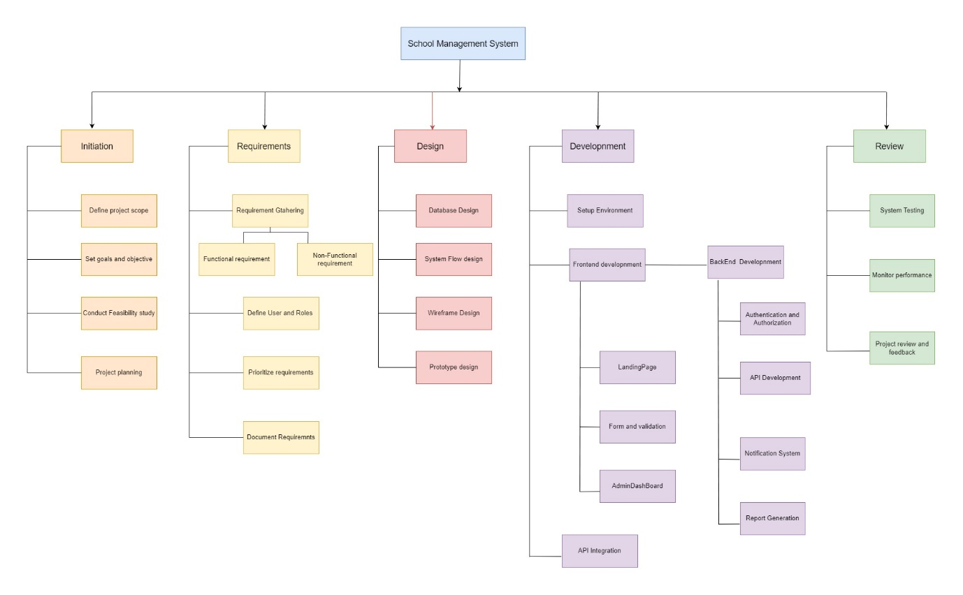
Figure 5: Work Breakdown Structure for the system.

8.Milestones:
- Project Finalization: Wrapped up the research and confirmed the project's goals, deliverables, and scope.
- Requirements Defined: After a meeting with the client, all the requirements were finalized as per their instructions.
- Design Completion: Developed and finalized wireframes, UI/UX prototypes, and system architecture.
- Development: Began development, working on both backend and frontend components of the project.
- Testing: Conducted testing by debugging issues and optimizing performance to ensure a reliable and high-quality output
- Handover & Documentation: Delivered the completed project along with a detailed report summarizing the work, challenges faced, and outcomes, emphasizing the value added through the process.
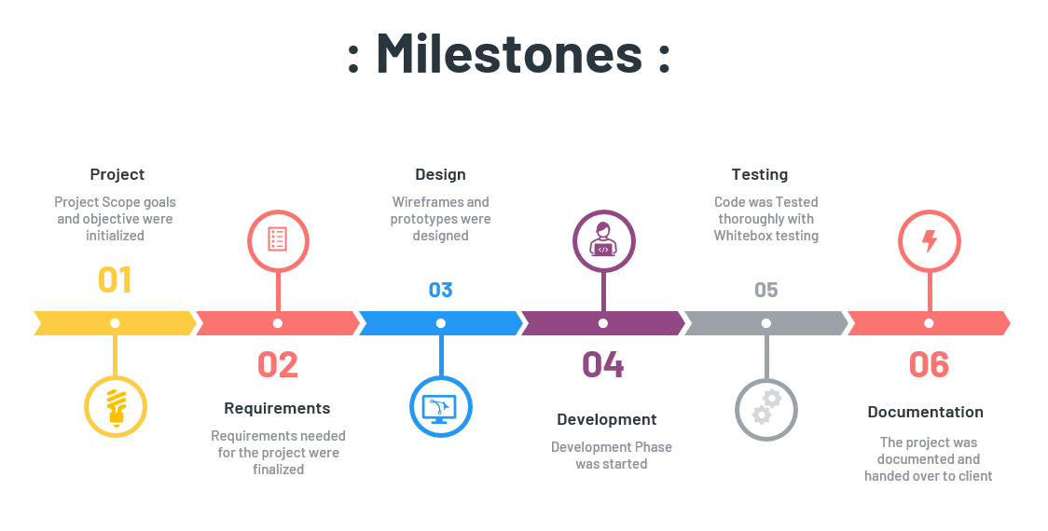
Figure 6 : Milestone Timeline for the System

9.Gantt Chart:
The chart below illustrates the work breakdown structure organized by time. As outlined in the milestones section, several key milestones are established throughout the project's duration. The project is expected to take approximately six months to complete, beginning with the initial research and planning phase and concluding with the final project submission. The timeline covers all critical stages, from securing the client and defining requirements to development, testing, and final reporting.

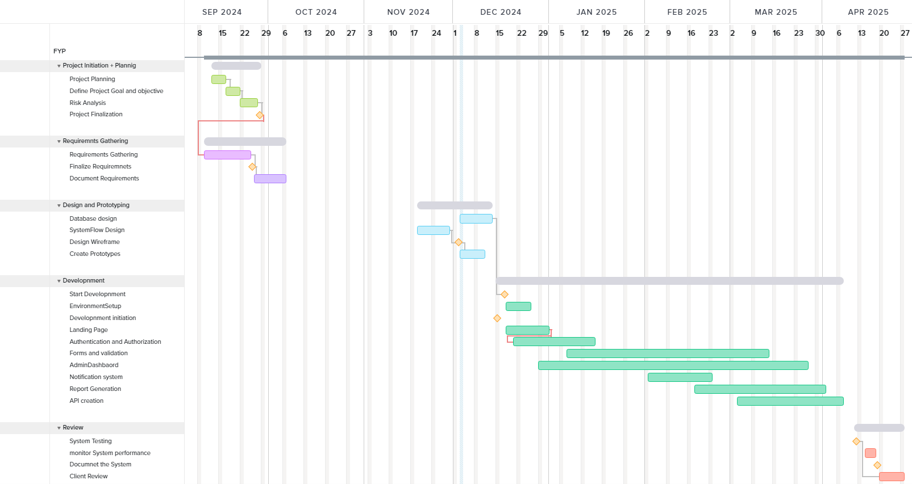
Figure 7: Gantt chart of the overall system

10.Conclusion:
In summary, by automating activities like enrollment, attendance monitoring, and fee administration, the School Management System project effectively meets the demand for more efficient educational procedures. The system guarantees effective administrative procedures and improves student participation through timely alerts. It demonstrates practical solutions that address real-world problems by implementing a dual enrolment procedure and addressing concerns like event overlaps and report generation delays.

The initiative lays a solid basis for future improvements, like adding sophisticated online payment tools and attendance systems. This project demonstrates how technology may revolutionize education by modernizing school processes while also fostering a more engaged and structured atmosphere for administrators, instructors, and students.

11. Bibliography:
Bhaskar S. (2024, November 21). What is Scrum Methodology? An Introduction for Agile Teams. Retrieved from nimbleWork: https://www.nimblework.com/agile/scrum-methodology/
edigitalnepal. (2024). Retrieved from https://edigitalnepal.com/p/the-current-scenario-of-education-system-in-nepal-how-digital-nepal-helping-to-schools-to-uplift-their-standard-3612
Grorapid Labs. (20024). Retrieved from https://www.grorapidlabs.com/blog/feature-driven-development-how-to-build-user-centric-products
MordorIntelligence. (2019-2024). Retrieved from https://www.mordorintelligence.com/industry-reports/school-information-management-system-market
Simon Buehring. ( 2024, April 3). Kanban board examples. Retrieved from https://agilekrc.com/agile/kanban/kanban-board/kanban-board-examples
theschoolmanagement. (2024). Retrieved from https://theschool-management.com/most-10-common-problems-in-school-management-system/
Verified Market Research. (2024). Retrieved from https://www.verifiedmarketresearch.com/product/school-management-software-market/

12.Appendix:
- Client Agreement Letter:
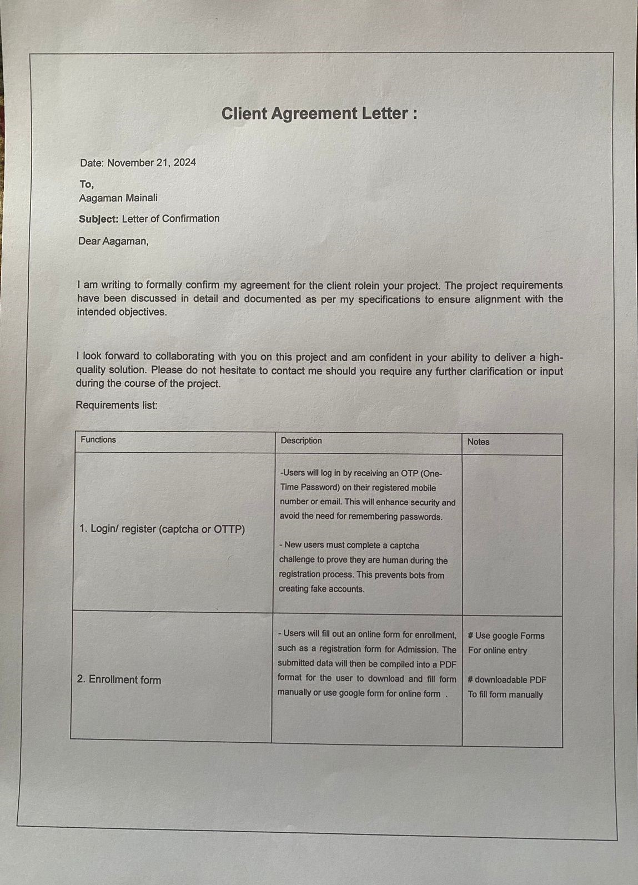
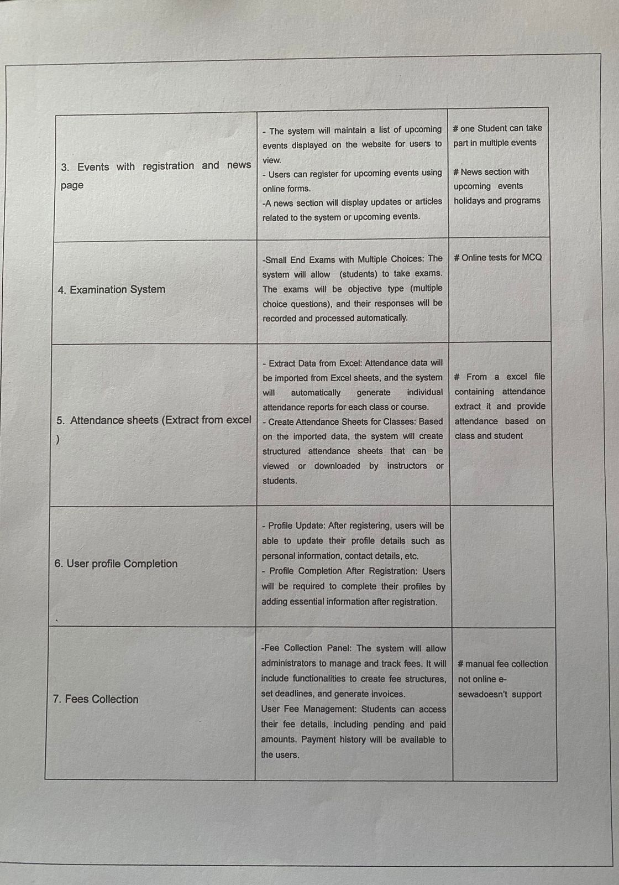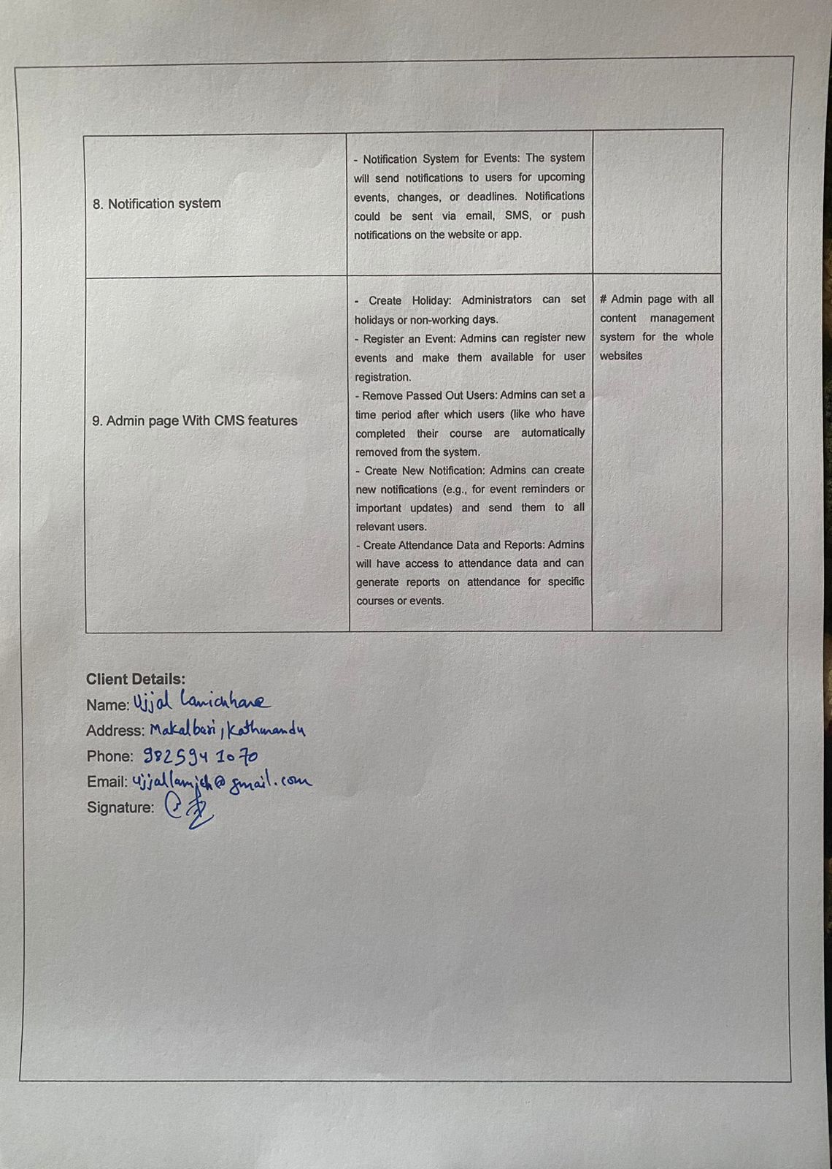

- Work Break down structure File:
https://drive.google.com/file/d/1wEVyDfVs0LCTZPDwzuJNb6G3raKcXUH1/view?usp=drive_link
- Gantt chart: https://drive.google.com/file/d/1XB_BO5ZvdB3l3GyBn4WlGnFihGnvgoWY/view?usp=drive_link
- Milestone
https://drive.google.com/file/d/19vQ-3uoN8l6e7COEbUgIrZKMluiL_ygp/view?usp=drive_link
- Turnitin Report: https://drive.google.com/file/d/1raH9FOb1tdhqEkI26P5oyy92JNN1_f87/view?usp=drive_link

